IMAGE SCRAPPER OUTPUT SCREENSHOTS

1. **chrome window screenshot fetching the images of given keyword:**

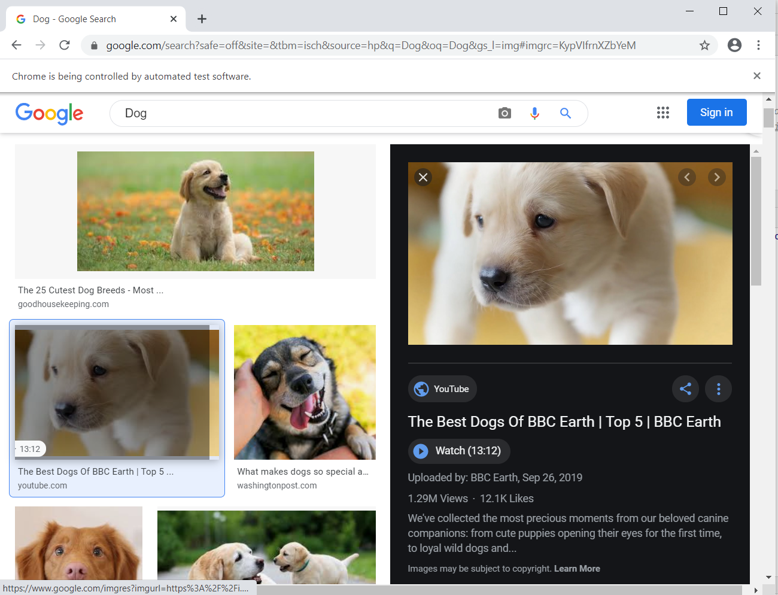

1. **Terminal screen shot>>>showing fetched image URL and success message**

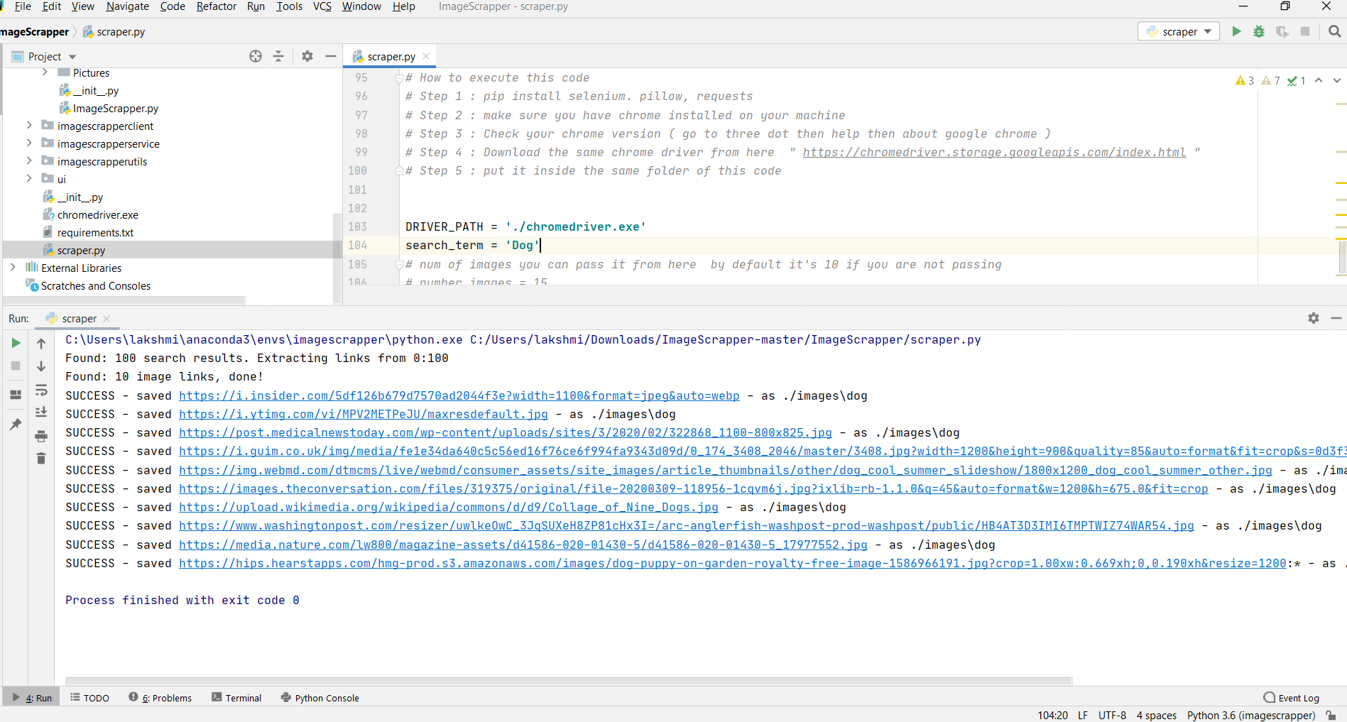

1. **Screen shot showing scrapped images saved in file location**

